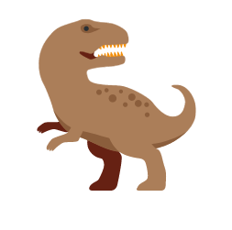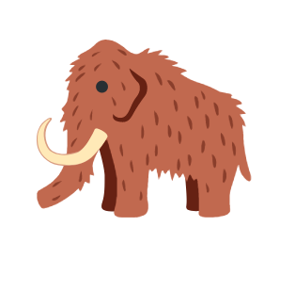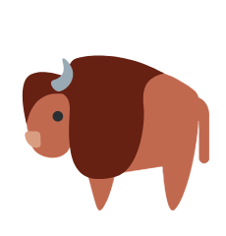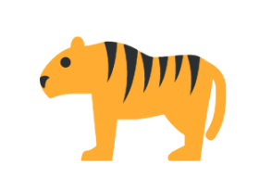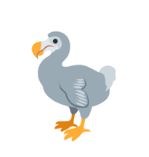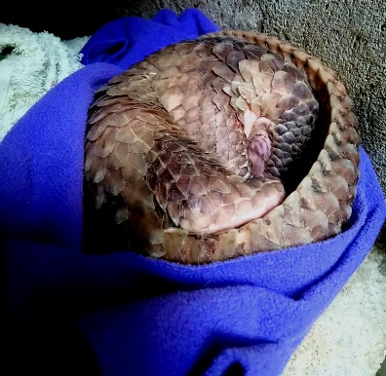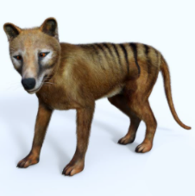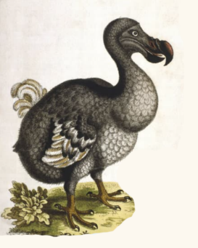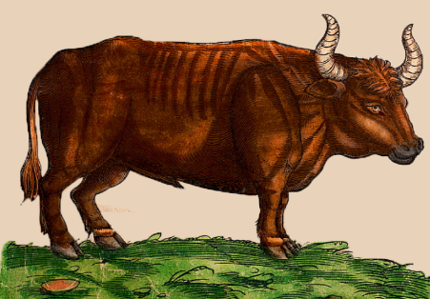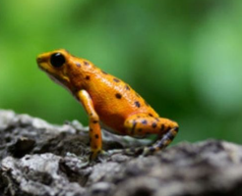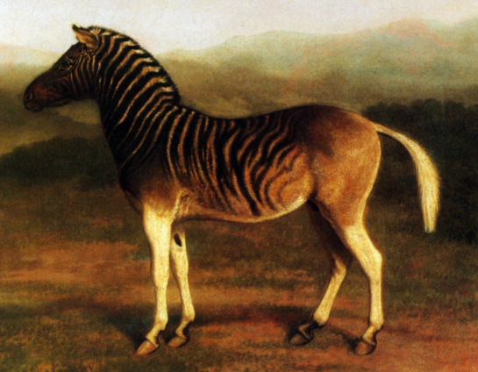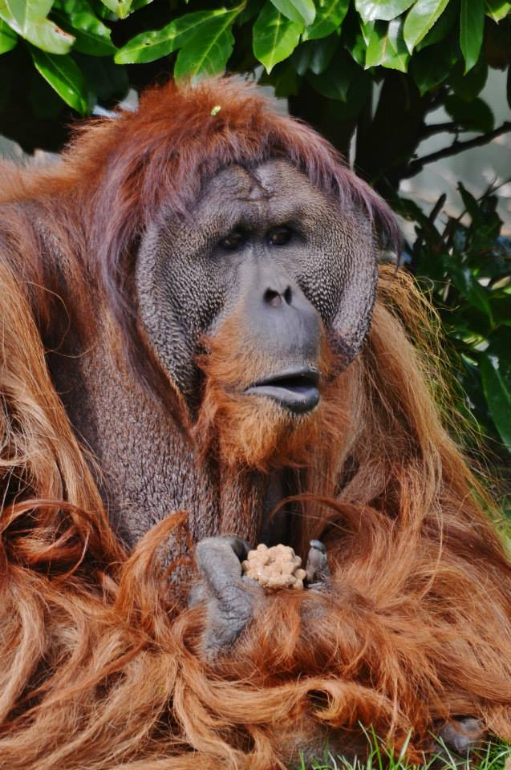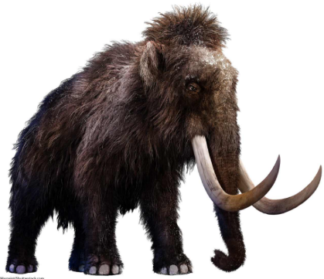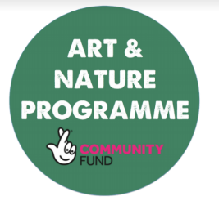

Pangolin

Thylacine

Dodo

Splendid Poison Frog

Auroch

Quagga

Orangutan

Woolly Mammoth

**Draw a circle around which of these animals you think is extinct.**

**What does “Extinction” mean? ________________________________________________________________________________________________________________________________________________________________________________________________________________________________________________**