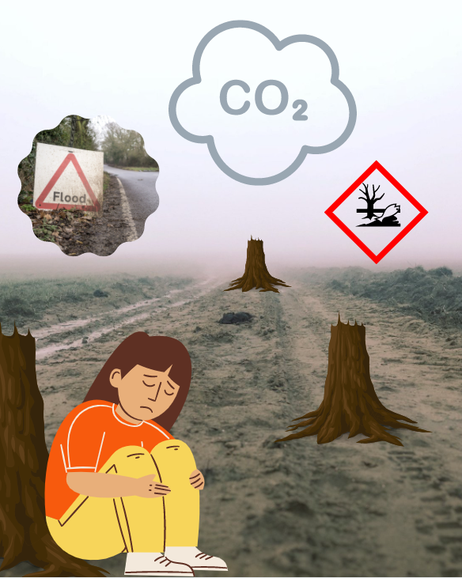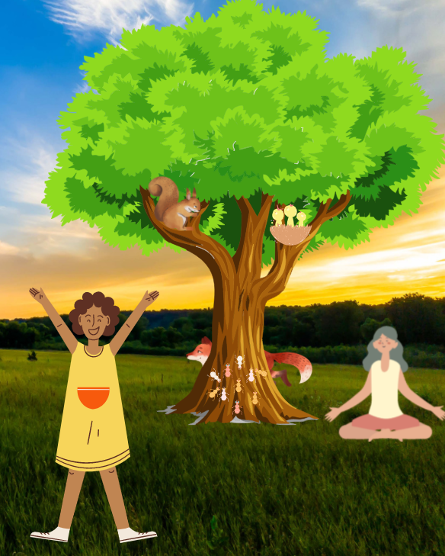

**From the differences you spotted, why are trees important?** _______________________________________________________________________________________________________________________________________________________________________________________________________________________________________________________________________________________________________________________________________________________________________________________________________________________________________________________________________________________________________________________________________________________________________________________________________________________________________________________________________________________________________________________________________________________________________________________________________________________________________________________________________________________________________________________________________________________________________________________________________________________________________________________________________________________________________________________________________________________________________________________________________________________________________________________________________________________________________________________________________________________________________________________________________________________________

**What Differences can you spot?** ________________________________________________________________________________________________________________________________________________________________________________________________________________________________________________________________________________________________________________________________________________________________________________________________________________________________________________________________________________________________________________________________________________________________________________________________________________________________________________________________________________________________________________________________________________________________________________________________________________________

**Spot the difference between the two images below. Then use the Importance of Trees Factsheet and the differences you have spotted to explain the importance of trees**