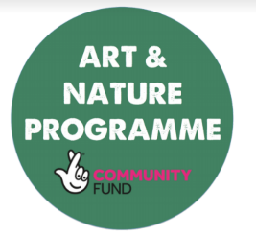

**There are lots of different symbols for peace, such as the ones below. Have a go at designing your own Peace Symbol, taking inspiration from the ones below or by creating something completely different. Once you have finished designing the symbol write an explanation about it.**

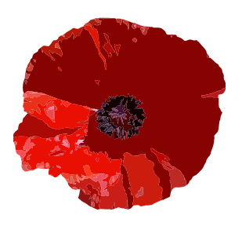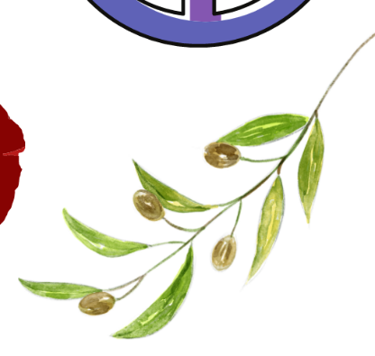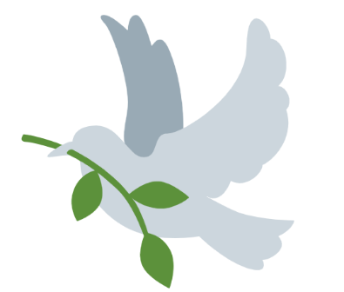

**__________________________________________________________________________________________________________________________________________________________________________________________________________________________________________________________________________________________________________________________________________________________________________________________________________________________________________________________________________________________**

**Olive Branch**

**Rainbow**

**Poppy**

**The peace sign**

**Dove**