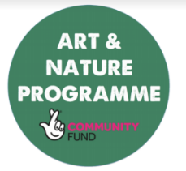

**Create your own dictionary! Write a definition for each of the words listed. Remember words in a dictionary are in alphabetical order.**



Poverty

Hunger

Rights

Desperate

Distress

Charity

Suffering

Nutrition

Global

Malnourishment

Poor

Inequality

________________________________________________________________________________________________________________________________________________________________________________________________________________________________________________________________________________________________________________________________________________________________________________________________________________________________________________________________________________________________________________________________________________________________________________________

________________________________________________________________________________________________________________________________________________________________________________________________________________________________________________________________________________________________________________________________________________________________________________________________________________________________________________________________________________________________________________________________________________________________________________________