|  |  |  |  |  |  |
| --- | --- | --- | --- | --- | --- |
|  | **On bark** | **On plants** | **In the sky** | **In soil** | **Under rocks/logs** |
| **Dragonfly** |  |  |  |  |  |
| **Snail** |  |  |  |  |  |
| **Bee** |  |  |  |  |  |
| **Spider** |  |  |  |  |  |
| **Ant** |  |  |  |  |  |
| **Butterfly** |  |  |  |  |  |
| **Woodlouse** |  |  |  |  |  |
| **Ladybird** |  |  |  |  |  |
| **Millipede** |  |  |  |  |  |
| **Beetle** |  |  |  |  |  |
| **Worm** |  |  |  |  |  |

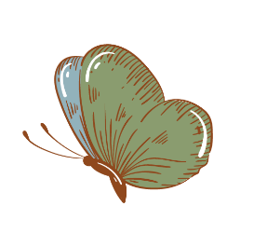

**Minibeast recording sheet**

**Where would you find these minibeasts? Complete with an X**