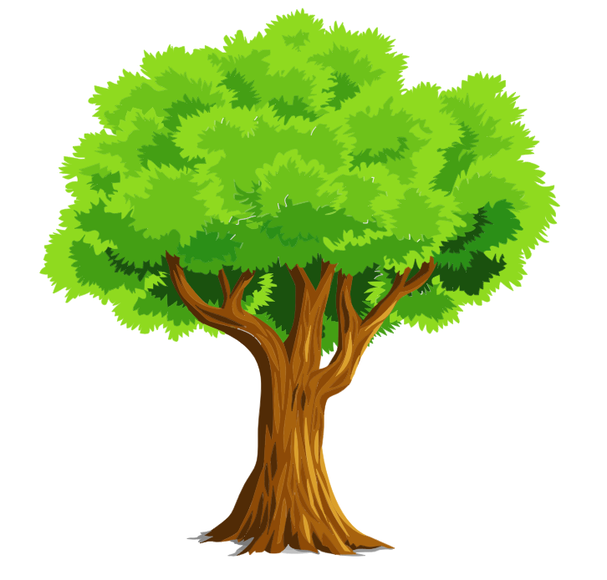

**Think of all the reasons that trees are important and write them on the lines ­­­­­­­­­­­­­­­­­­­­­**

**______________________________________________________________________________________________________________________________________________________**

**______________________________________________________________________________________________________________________________________________________**

**______________________________________________________________________________________________________________________________________________________**

**______________________________________________________________________________________________________________________________________________________**

**_____________________________________________________________________________________________________________________________**

**______________________________________________________________________________________________________________________________________________________**

**The Importance of trees**