**Use the lines below to organise your thoughts and ideas about what it means to be a Global Citizen**

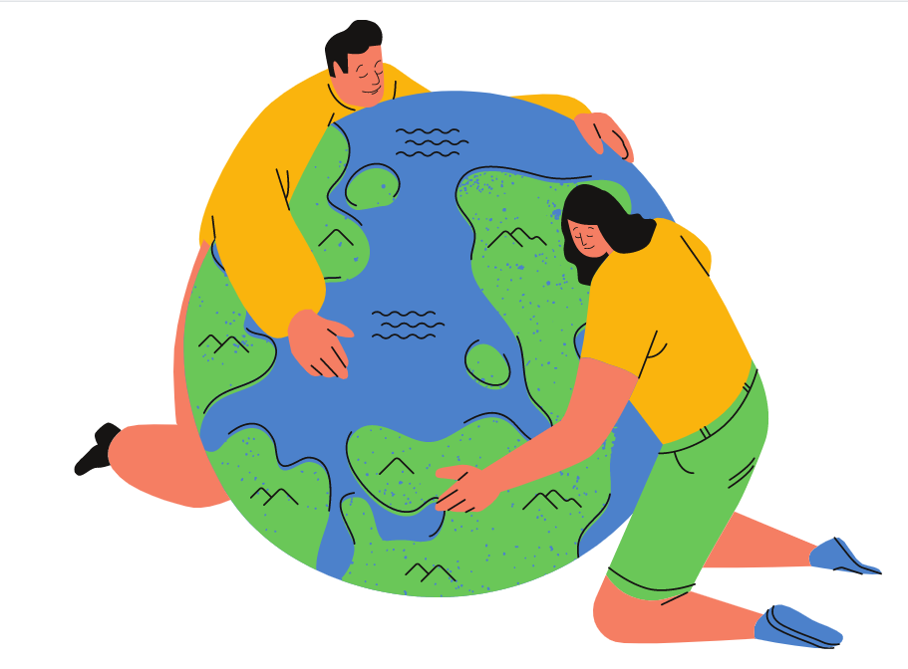

**Other questions or thoughts?**

**__________________________________________________________________________________________________________________________________________________________________________________________________________________________________________________________________________________________________________________________________________________________________**

**_____________________________________________________________________________________________________________________________**

**Where would you find a Global Citizen?**

**______________________________________________________________________________________________________________________________________________________**

**What does a Global Citizen do?**

**_____________________________________________________________________________________________________________________________**

**Who is a Global Citizen?**

**What does Global Citizen mean?**

**_________________________________________________________________________________________________________________________________________**

**Global Citizenship**