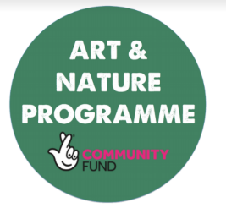

**Design something inspired by your favourite artist and answer the questions**

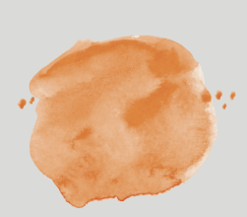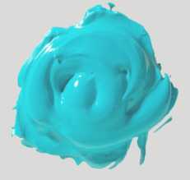

**Tell me about your design** _______________________________________________________________________________________________________________________________________________________________________________________________________________________

**How did you come up with this design?**

_______________________________________________________________________________________________________________________________________________________________________________________________________________________

**What inspired you?** _______________________________________________________________________________________________________________________________________________________________________________________________________________________