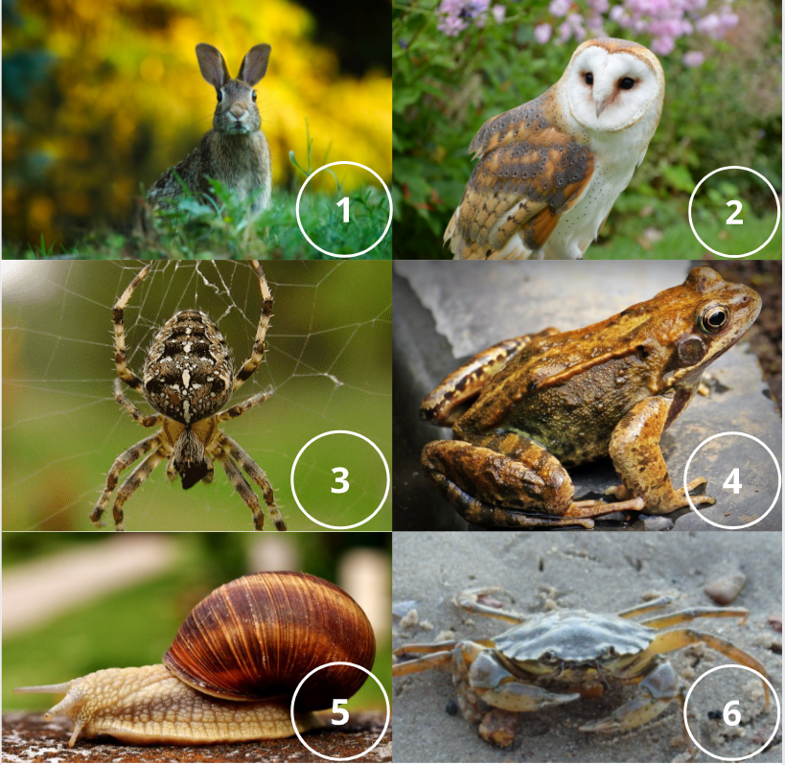

**Use the classification key and factsheets to help you classify and name each of these British animals**

**1.**

**2.**

**3.**

**4.**

**5.**

**6.**