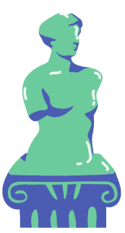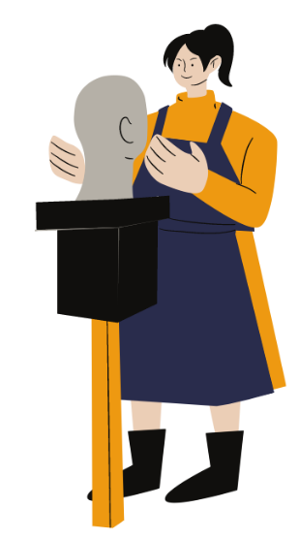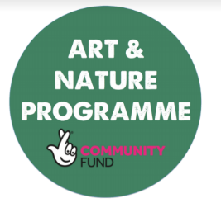

**Answer the questions**

1. Name all the types of art you can think of

__________________________________________________________________________________________________________________________________________________________________________________________________________________________________________________________________________________________________________________

2. What types of art do you enjoying doing?

________________________________________________________________________________________________________________________________________________________________________________________________________________________________________________________________________________________________________________________________

3. Where in your local town where you have seen art?

________________________________________________________________________________________________________________________________

4. Do you have a favourite piece of art you have seen?

________________________________________________________________________________________________________________________________

5. Who made it, and where were they from?

________________________________________________________________________________________________________________________________

6. Why do you like it?

________________________________________________________________________________________________________________________________________________________________________________________________________________________________________________________________________________________________________________________________

Does the art reflect the area it came from? ____________________

______________________________________________________________________________________

Is there a lot of art inspired by your area? Do we need more?

_____________________________________________________________________________________________________________________________________________________________________________